
SCHOOL OF COMPUTING AND ENGINEERING SCIENCES (SCES)
BACHELOR OF SCIENCE IN ELECTRICAL AND ELECTRONICS
ENGINEERING (BSEEE)
COMMUNICATION SYSTEMS
Lab 2:
AMPLITUDE MODULATION AND DEMODULATION IN COMMUNICATION SYSTEMS

BY
Edward Mwongela
142092

Lecturer: Prof. J. Obadha.
29th October 2024

Table of Contents
List of figures 2
Abstract: 3
Chapter 1: Introduction 4
Objectives: 4
Theoretical Analysis: 4
Chapter 2: Methodology 5
Apparatus Required: 5
Procedure Followed: 6
Chapter 3: Results 7
Findings and Outcomes: 7
1. Scope1 Results: 7
2. Scope2 Results: 8
Chapter 4: Conclusion & Recommendations 10
Conclusion: 10
Recommendations: 10
References: 10

List of figures
Figure 1. schematic and expected signal 5
Figure 2. simulink schematic 7
Figure 3. scope results 1 8
Figure 4. scope results 2 9

Abstract:
This experiment investigates amplitude modulation (AM) and demodulation using Simulink software. The purpose was to modulate a sinusoidal message signal with a carrier signal and then demodulate it to retrieve the original signal. Simulations were conducted to observe the characteristics of AM signals and verify the accuracy of the demodulation process. The results confirmed successful modulation and demodulation confirming theoretical expectations, illustrating how AM facilitates signal transmission in communication systems. This report consolidates key observations, theoretical implications, and practical applications.

Chapter 1: Introduction

Objectives:
The objective of this experiment is to demonstrate amplitude modulation by modulating a low frequency message signal with a higher frequency carrier signal, followed by demodulation to retrieve the original message. This process is foundational in many communication systems, where AM is used to transmit information over long distances.

Theoretical Analysis:
Amplitude Modulation (AM) is a telecommunications technique where the amplitude of a high-frequency carrier wave varies in proportion to a low-frequency message signal, allowing information to be carried from source to destination. The carrier’s fixed frequency is modified by the message signal’s amplitude, creating sidebands around the carrier frequency. Demodulation at the receiver end then extracts the original message signal. Proper management of the modulation index (m) - the ratio of the message signal amplitude (Am) to the carrier signal amplitude (Ac)—is essential to prevent overmodulation, which can lead to signal distortion. This experiment uses Simulink to simulate AM modulation and demodulation, visually demonstrating these signal transformations essential for reliable communication.

Chapter 2: Methodology

Apparatus Required:
Simulink software for signal modeling and simulation
Computer for running simulations
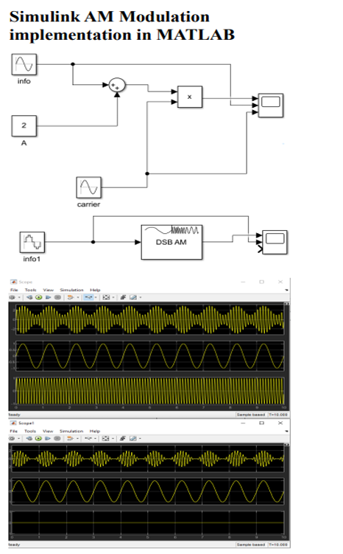
Figure 1. schematic and expected signal

Procedure Followed:
1. Signal Generation:
Generated a sinusoidal wave with a frequency of 1 Hz to serve as the message signal.
Generated a carrier signal with a frequency of 10 Hz to act as the carrier.

2. Modulation:
Combined the message and carrier signals using an adder block.
Applied AM using a Double Sideband Amplitude Modulator (DSB AM) block.

3. Visualization:
Observed the modulated signal on Scope1 to analyze its characteristics.
Used an appropriate demodulation setup to retrieve the message.
Observed the demodulated signal on Scope2, comparing it with the original message.

Chapter 3: Results

Findings and Outcomes:
The experiment produced several key visual outputs that confirmed the successful modulation and demodulation of the AM signal:
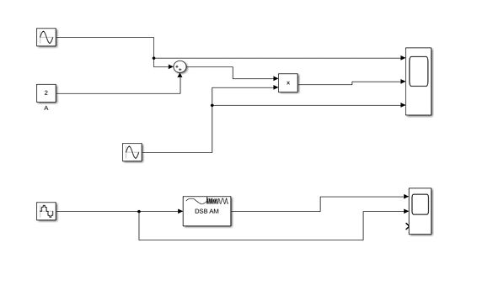
Figure 2. simulink schematic

1. Scope1 Results:
The top subplot displayed the original sinusoidal message signal.
The middle subplot showed the carrier signal.
The bottom subplot illustrates the amplitude-modulated (AM) signal.

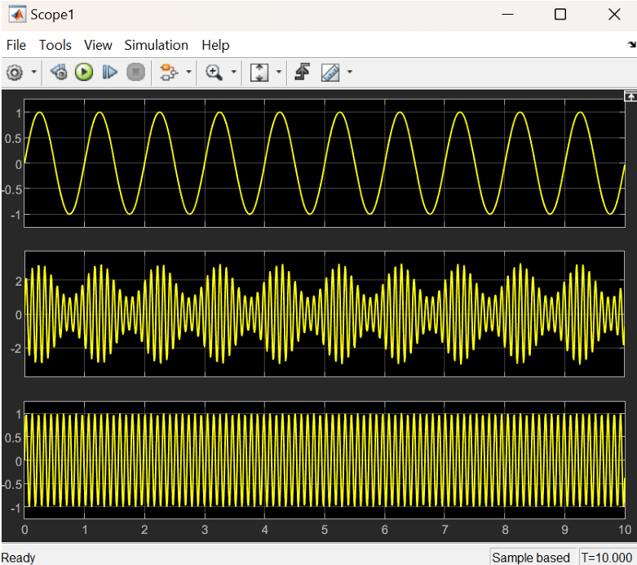
Figure 3. scope results 1

2. Scope2 Results:
The top subplot displayed the demodulated signal, closely resembling the original message signal.
The middle subplot presented the original message signal for comparison.

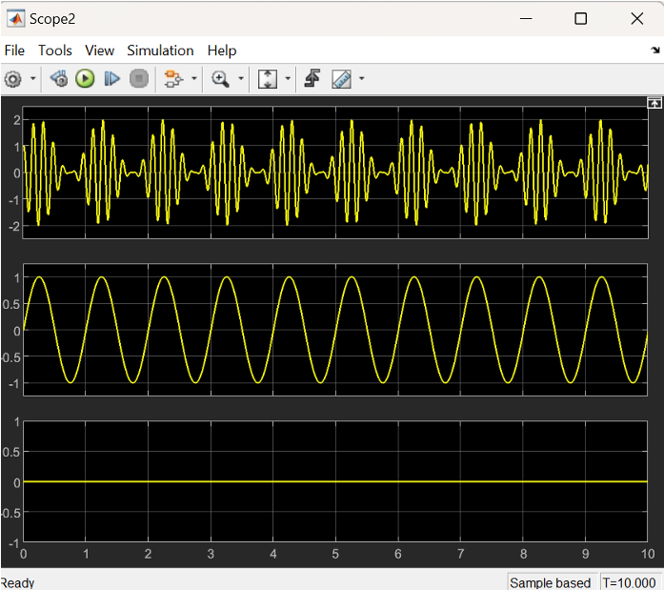
Figure 4. scope results 2
The modulated signal displayed in Scope1 confirmed that the amplitude of the carrier wave was being modulated by the message signal. Scope2 demonstrated that the demodulation process effectively retrieved the original message signal, with only minor discrepancies possibly due to simulation constraints or settings in Simulink.

Chapter 4: Conclusion & Recommendations

Conclusion:
This experiment successfully demonstrated the fundamental processes of amplitude modulation and demodulation using Simulink. The modulated signal effectively encoded the message signal, and the demodulation process accurately retrieved the original information. This confirms the practical applicability of AM in communication systems and reinforces its importance in signal transmission.
The experiment was also tried on proteus but showed a lot of errors at the schematic design phase and thus had to resort to matlab for continuation of the lab

Recommendations:
Future experiments could explore additional modulation techniques, such as frequency modulation (FM), and compare their effects on signal integrity. Additionally, adjustments to Simulink parameters may yield even closer alignment between the demodulated and original signals, enhancing the accuracy of the findings.
Try the same design on proteus to resolve previous failure.

References:
Simulink Documentation
Coursework Manual

